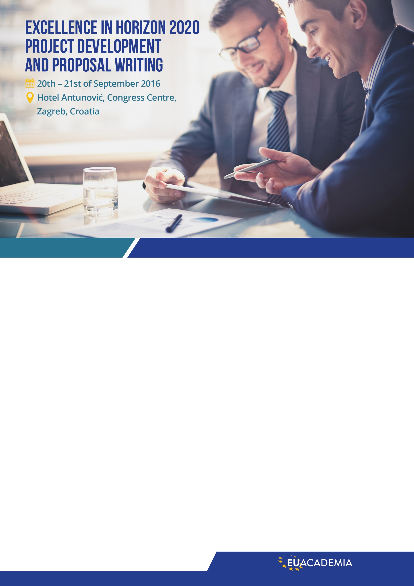

EU Academia | T: 00386 40 772 267 | E: info@eu-academia.com | W: http://www.eu-academia.com

**Register now**

Course Overview

The European Union will invest almost €16 billion in research and innovation in the next two years under Horizon 2020, the EU’s research and innovation funding scheme, following a new Work Programme for 2016-17 adopted in October 2015. The Horizon 2020 programme target is to remain Europe lading in strategic science, to master societal challenges (e.g. environment, health) and to sustain industrial leadership (e.g. eco-mobility infrastructure, factory of the future). The involvement of Small and Medium-sized Enterprises (SMEs) is given a key attention to carry out innovation and through this creating and sustain employment.

Getting up to speed with the latest developments and the previous results and funding priorities for new H2020 calls will improve your chances tremendously to be included in projects running for the whole period till 2020.

You will be **trained, advised and coached on how to participate in the open upcoming calls** based on the new Work Programmes and intensive consultations with the relevant officials. This challenging two-day programme is designed for professionals seeking excellence in the EU project development and proposal writing. Furthermore, it will offer effective strategies and tools to those who wish to take part as partners in H2020 projects.

The program develops competencies and skills for initiating and implementing projects satisfying the highest quality criteria and understanding stakeholder issues that enable high impact and sustainability. We shall be building the capacity of project leaders to put in practice the most advanced methodologies for EU project management and leadership from project idea to follow-up.

Experiential learning environment encourages active interplay between conceptual frameworks and their implementation in complex real-world settings. Focusing on new EU funding opportunities we shall examine full project development process identifying key variables for success at each stage and providing irreplaceable insights into best practices;

Due to new political realities, migrants and energy crises, policy changes for the Balkans, Russia and Mediterranean countries, participants will be provided with the exerts guidance for the newly emerging funding and intervention opportunities.

You will benefit from analysis of specific calls for proposals performed by the leading EU authorities, the best partners to establish an international consortium, consensus-driven discussions to define project outline, proposal writing by experienced experts or insight to the EC evaluation criteria from experienced evaluators. As an added value training is based on practical work on participants concrete project proposals under supervision of leading EU experts, interconnecting initiatives that may reinforce each-other.



EU Academia | T: 00386 40 772 267 | E: info@eu-academia.com | W: http://www.eu-academia.com

08:30 – 09:00 Registration of participants

09:00 – 10:00  
**PRACTICAL ANALYSIS OF PARTICIPANTS PROJECT INITIATIVES**  
Analysis of participant’s profiles, project concepts or proposal texts  
Expert’s evaluation of ongoing project initiatives

10:00 – 11:45  
**WORKSHOP – WRITING OF IMPACT**  
What is Impact, why is important and how it is evaluated  
How to write Impact, key factors for excellent Impact  
Workshop: Writing sections on Excellence and Impact

11:45 – 12:00 Coffee break

12:00 – 13:00  
**EXCELLENCE IN PROJECT PROPOSAL WRITING H2020**  
The philosophy of writing successful EU projects  
Learning how to be competitive: the most advanced tools for success in proposal writing  
Providing evidence: How to make the project easy to read and how to impress the evaluators

13:00 – 13:30 Snack break

13:30 – 14:30  
**WORKSHOP – PROJECT PROPOSAL EVALUATION**  
Example of the successful project proposal  
Exercise: Evaluation of already submitted H2020 project proposals; analysis of project proposals; why has EC given money to one project proposal and rejected another one

14:40 – 14:45 Coffee break

14:45 – 15:45  
**COACHING SESSION**  
Practical advices from the authorities concerning participant’s concrete project initiatives.  
Individual and group coaching in project design or consortium creation.  
Refining participant’s action plans.

15:45 – 16:00  
**COURSE SUMMARY AND DISCUSSION**

08:30 – 09:00 Registration of participants

09.00 – 10.00  
**WELCOME SPEECH AND PANEL DISCUSSION**  
about new funding priorities and new political realities

10:00 – 10:30  
**INTRODUCTION – EXPECTATION OF THE EUROPEAN COMMISION**  
Getting to know the latest changes, challenges and obstacles on the path to EU funds

10:30 – 11:15  
**EU PROGRAMME FOR RESEARCH AND INNOVATION – HORIZON 2020**  
Guidance notes to get into H2020 different thematic fields focused on new calls,  
based on participant’s interests and successful experiences from the beginning of the programme

11:15 – 11:30 Coffee break

11:30 – 12:15  
**H2020 CALL ANALYSIS WORKSHOP**  
Exercise: Finding topics and calls for proposals  
Exercise: Call analysis, understanding expectations of the EC  
Exercise: Understanding adequate evaluation criteria for different H2020’s types of actions

12:15 – 13:00 Snack break

13:00 – 14:00  
**PROJECT DEVELOPMENT TOOLS**  
The entire process of proposal preparation  
Masters tools for project design  
Workshop: Designing project proposal WBS in line with evaluation criteria  
Practical tips and advices for proposal preparation

14:00 – 14:15 Coffee break

14:15 – 15:45  
**PARTNER SEARCH AND PROFILE DEVELOPMENT**  
Exercises: Develop your profile, practical guide to profile development  
Exercises: How to reach the right attention, practical guide to find the right consortium

15:45 – 16:00  
**DISCUSSION WITH LECTURERS**

Course Programme



EU Academia | T: 00386 40 772 267 | E: info@eu-academia.com | W: http://www.eu-academia.com

**THE SUCCESS**

Our programs has already been highly evaluated by more than 6000 participants from respectable institutions and successful companies in the region including: **Hewlett Packard, Société Générale Bank, KBC Bank, VIP Mobile, Tigar, 3M, Siemens; Leading Universities,** numerous small companies and entrepreneurs, NGOs, Ministry departments, City councils, Municipalities, etc..

**TRAINING PRICE**

**Full course (2 days):**389€ (VAT excluded) for registration before 16.9.2016

439€* (VAT excluded) for registration after 16.9.2016

**One day course:**199€ (VAT excluded) for registration before 16.9.2016

220€* (VAT excluded) for registration after 16.9.2016

The Workshop price includes attendance at the workshop, copy of workshop materials, lunch and refreshments.

**Who should participate?**

* Professionals from all sectors: academia, universities and faculties, research institutes, SMEs, large industries, consultancies, clusters, national ministries and local authorities, regional development agencies, civil society organizations, NGOs etc.
* Professionals from all sectors who would like to improve their project development skills to increase their chances of submitting a winning proposal
* Professionals from all sectors who have been participating in H2020, FP7 or CIP projects
* Professionals from all sectors who intend to participate in Horizon 2020

**Your major benefit of this 2-day intensive training?**

Master the logic and structure of Horizon 2020, the techniques of project planning and the role of partners in an Horizon 2020 consortium. Design a convincing and consistent proposal exceeding the requirements of the European Commission and impressing evaluators.

**Dr. Andrej Grebenc**

He is working at European Commission for over a decade, involved in FP7 projects since the start of the programme in 2007, participated in preparation of new EU programme for research and innovation H2020, FP7 and Horizon 2020 Programme Management; worked as Motorways Tunnel Manager at Ministry of Transportation – DARS and as Project and Program Manager for numerous organizations. Andrej has a wide range expertise in different areas like ICT, Energy, Transportation, Security, both in public and private sector. Extensive experience and cooperation with diverse stakeholders for horizontal topics.

**Prof. dr. Steve Quarrie**

He is Head of education in European Training Academy. He provided regular training courses for over 15 years to scientists in Europe on general skills needed to develop a successful career doing science and research, including how to write project proposals. These courses have also been given in Newcastle, UK, Skopje, Macedonia, Zagreb, Croatia, Krakow, Poland and many reputable Universities and Centers of Excellence. He teaches general research skills to PhD students at the Faculty of Biology, Belgrade University, and is also a visiting Professor at the Business School, Newcastle University, UK. He has been a proposal evaluator for the European Commission in Brussels, and was a consultant for Serbia’s first Accreditation Commission for Higher Education. He has taken part as an independent expert in several Tempus projects, providing expertise in quality control and improving lecturer teaching skills. Steve has written more than 10 successful EU-funded projects, with success rate in writing research (FP) projects over 50%.

**guest speakers**

Guest speakers from the EU institutions covering critical political topics and COSME program are expected to lead and contribute to the panel discussion at the beginning of the first day. Due to new political realities, migrants and energy crises, policy changes for the Balkans, Russia and Mediterranean countries, organizers will ensure exerts guidance for the emerging funding and intervention opportunities.

Speakers

**Title** (Mr, Mrs, Ms, Miss, Dr, Prof) **Name** First Last

**Organisation / Company**

**Position in Organisation / Company**

**Invoice Address City Post code**

**Country**

**Email Phone**

**VAT Identification Number (IF APPLICABLE):**

**Signature**

**Booking Procedure:** once this form is completed and signed please send to email: **info@eu-academia.com**Once this completed form is received, an invoice plus confirmation of your booking will be issued.**Cancellations:** Cancellation may be made 3 days prior to the event (no later than 16.9.2016) without penalty. The total amount you will be returned to your account. In case of cancellation after this date (16.9.2016), we charge 90% of the paid fee.

**General Inquiry** + 386 40 772 267

**General Inquiry**info@eu-academia.com**Registration**registration@eu-academia.com

**20th – 21st of September 2016**

**Hotel Antunović, Congress Centre  
Zagrebačka avenija 100  
10090, Zagreb, Croatia**

**Please check whether you are applying for a full course or one day course**

**Full course (2 days) - 389€** (VAT excluded) for registration before 16.9.2016**One day course - Day 1 - 199€** (VAT excluded) for registration before 16.9.2016**One day course - Day 2 - 199€** (VAT excluded) for registration before 16.9.2016

**You can register online at our website** [**http://www.eu-academia.com/registration/**](http://www.eu-academia.com/registration/%20) **or by filing out form below.**

Registration form